Creating a NEW account and Register with Ottosport

Create your SYSA account using this link, https://spokaneyouthsports.ottosport.ai/_registration Initial screen where members click on the public registration link. New members will click Begin Registration
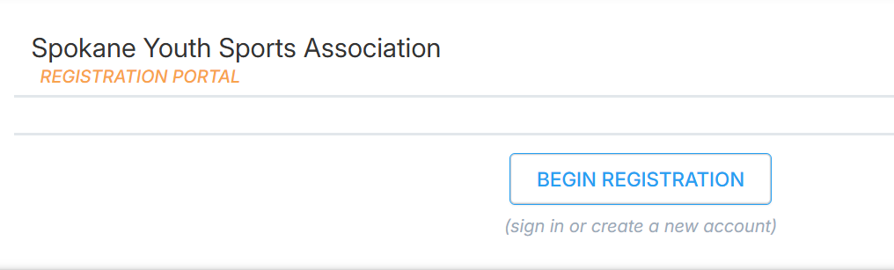
Click "Create New Account"
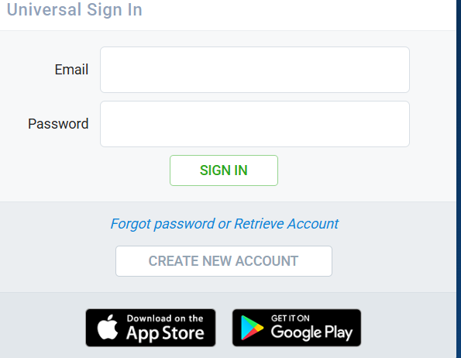

Complete the new account information
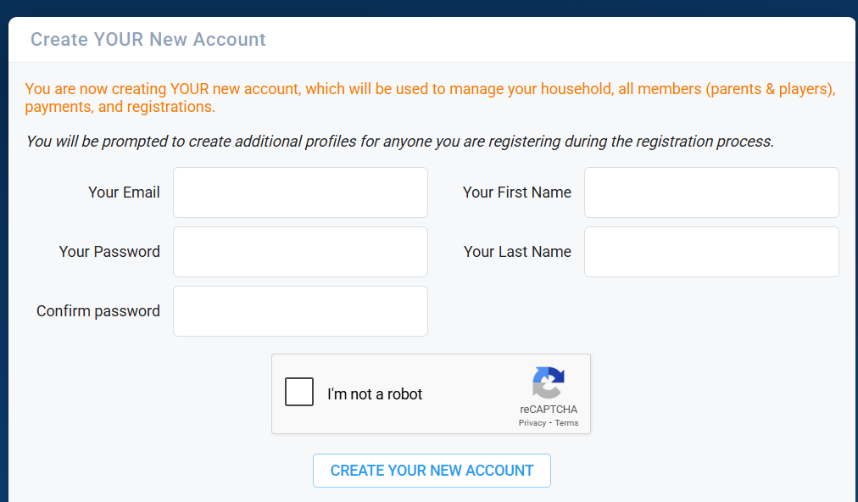

Once the account is created, enter household information. The Household name will auto-populate as the last name of the person creating the account.
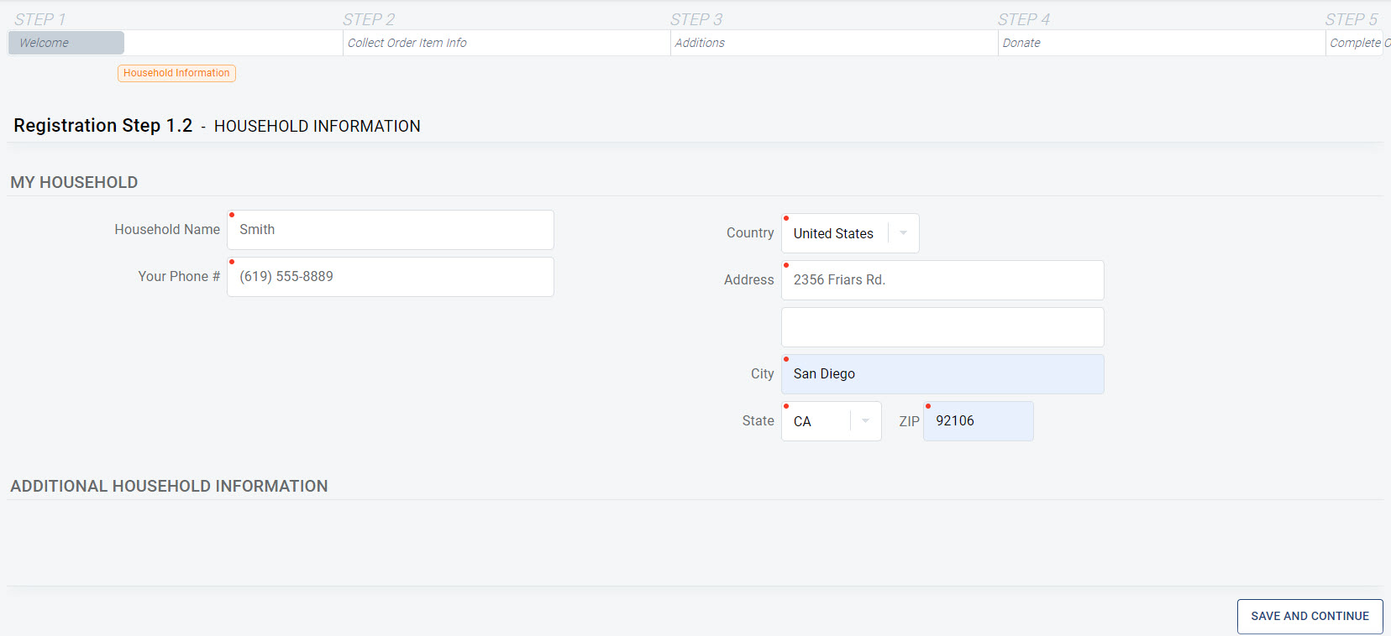

Click continue to register, click register a participant/player
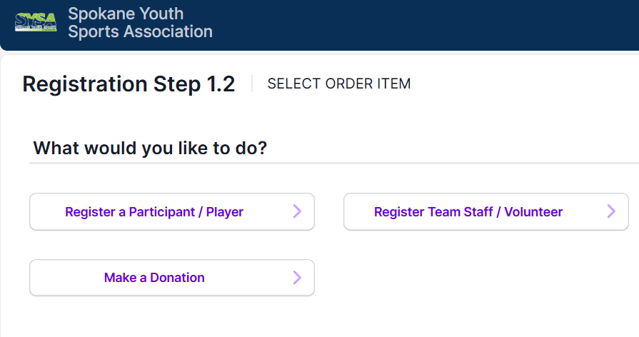
Click Create New Member and enter your child’s information, click save and continue

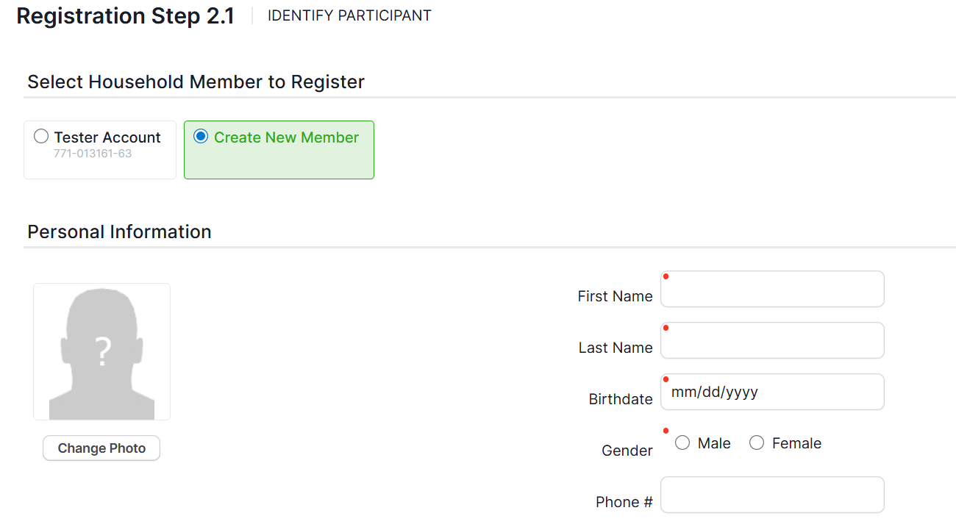

Select Season you want to register for
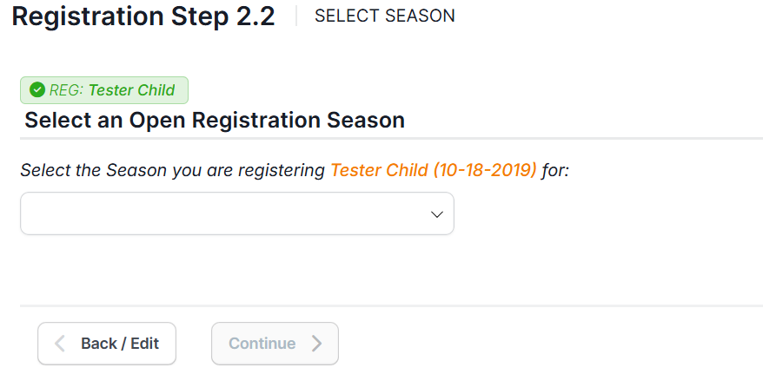
Select registration, program information is listed below these selections
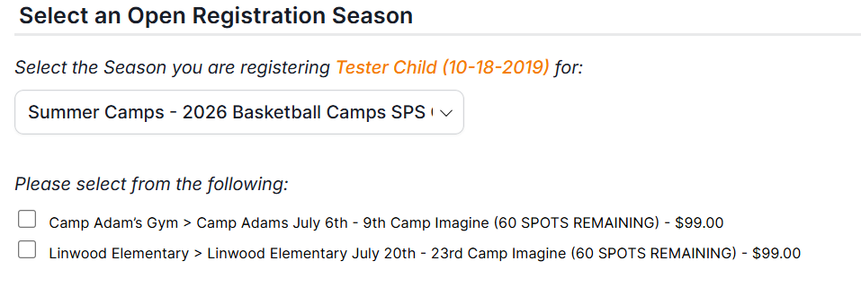

Complete parent information. You can also add another member of your household to add to your account. Complete Emergency contact information.
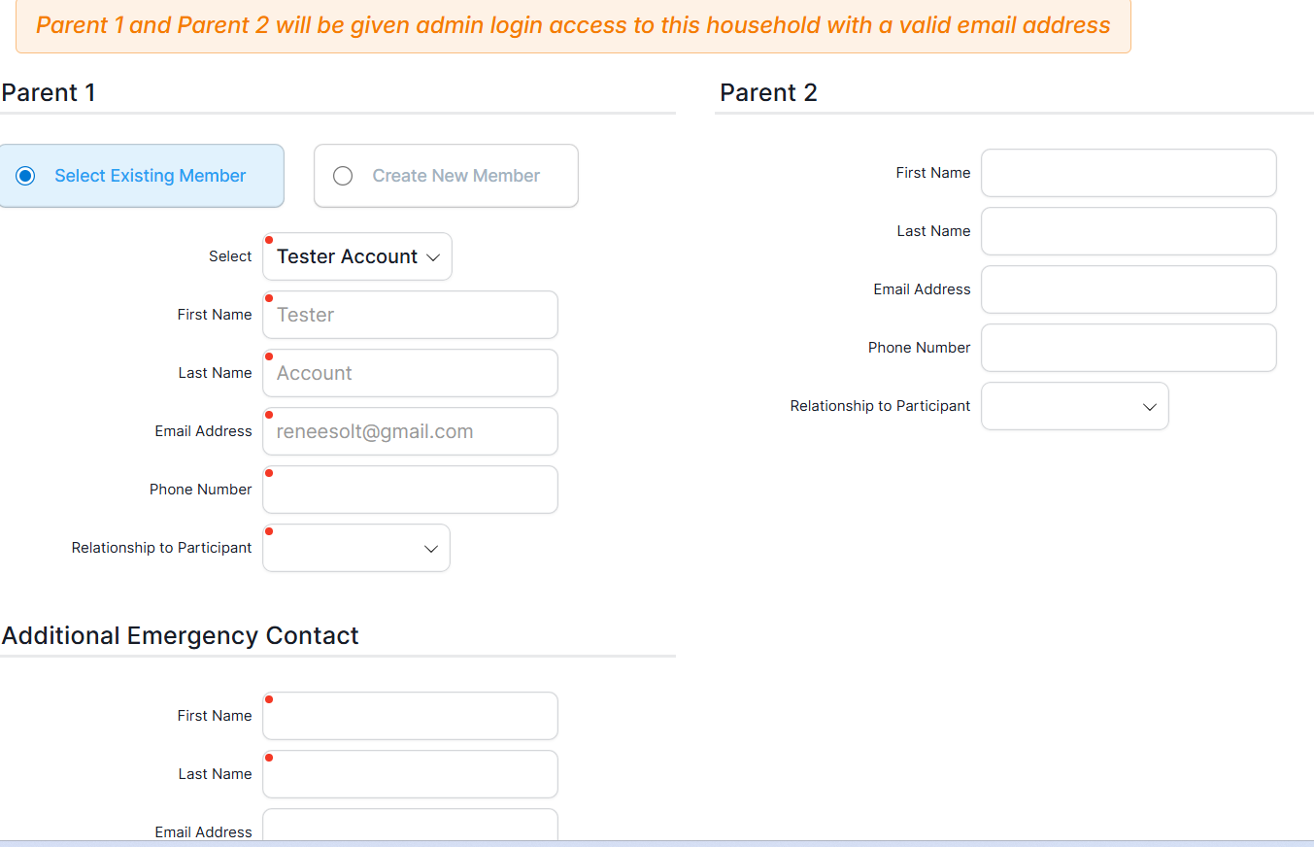

Complete program questions
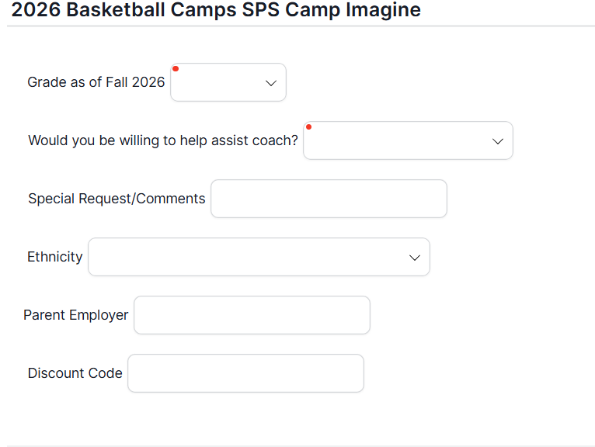
Coaching Opportunities
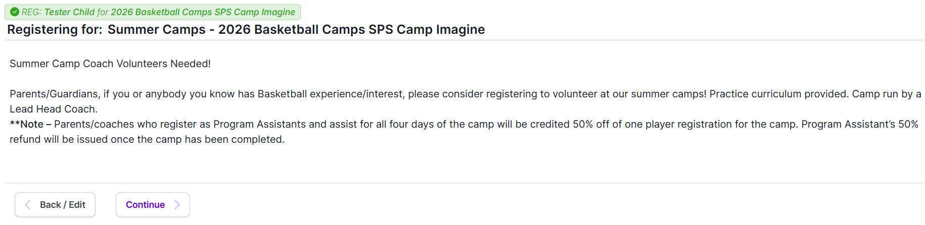

Register to coach here, or click no to continue
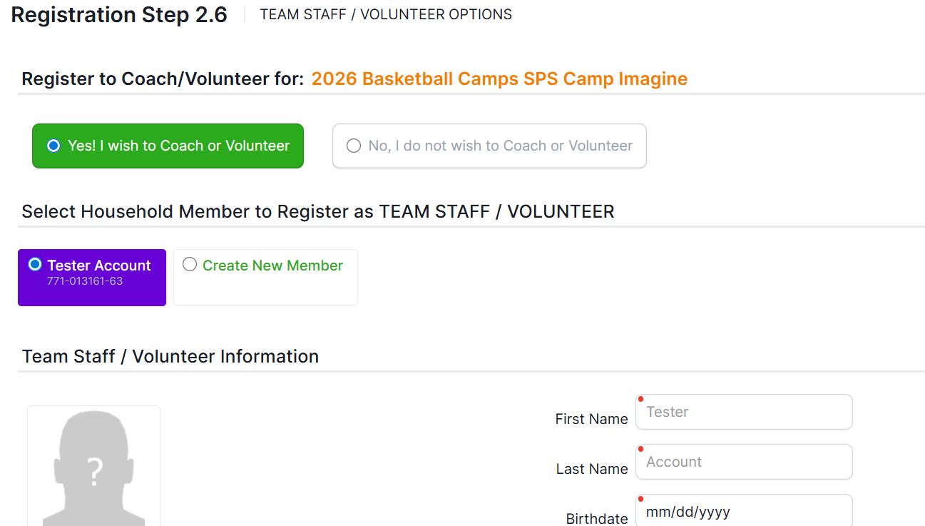

Review your registration here
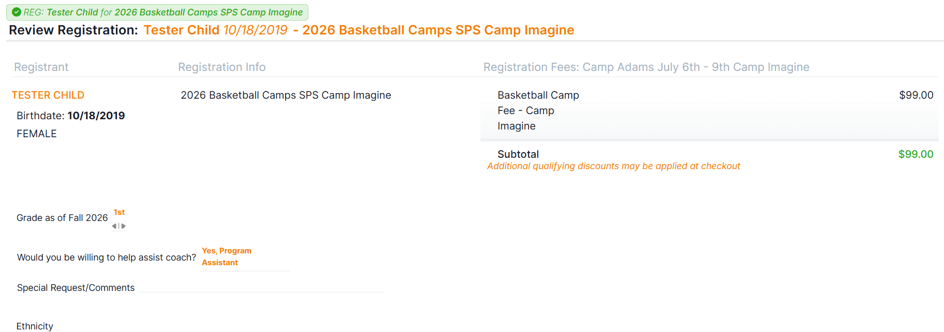

Review Seasonal Waivers and sign off
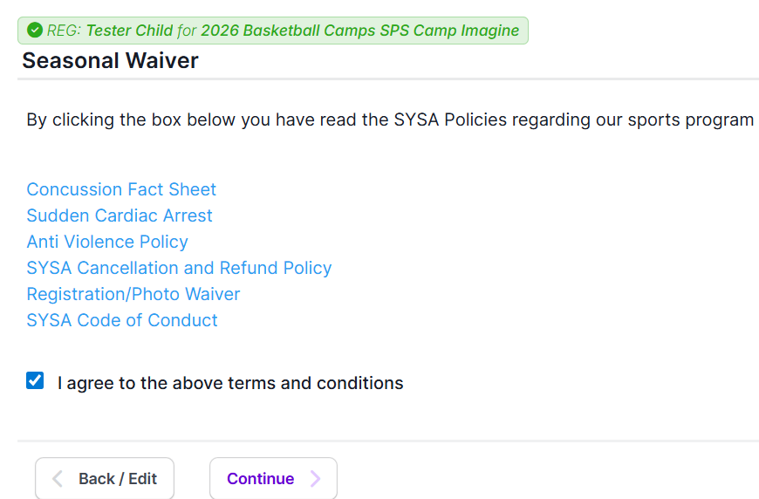

Register another player or continue to check out
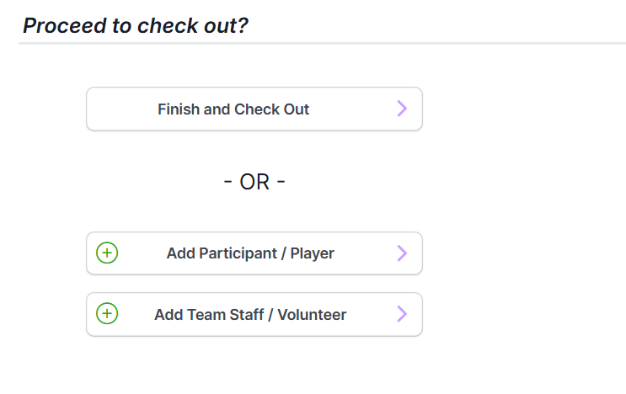

Review registration again, select payment method, input payment information and submit order
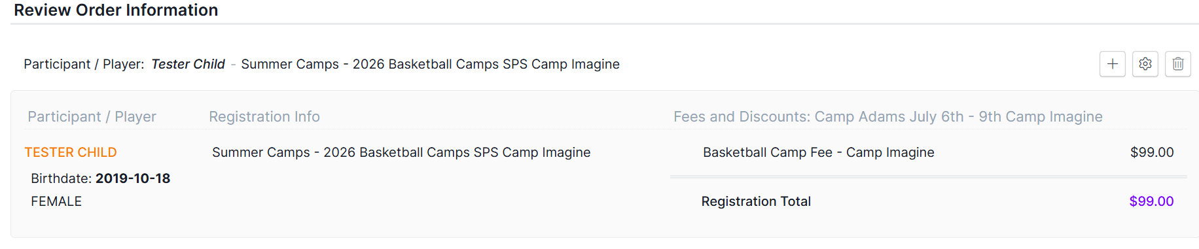
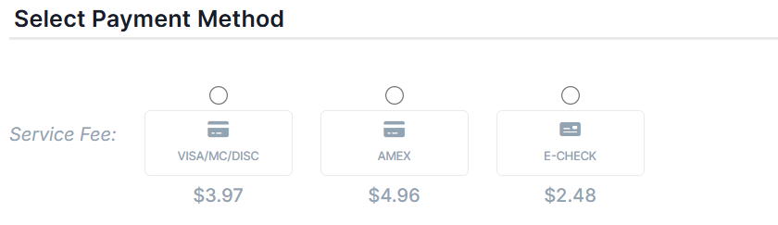

To ensure your registration is complete, check your email for a confirmation email
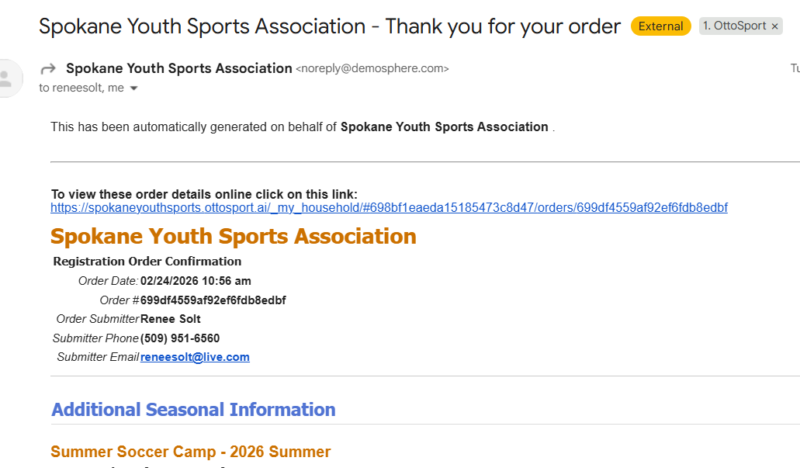
Registration problems please contact receptionist@sysa.com

